English with Science in Scratch

Subject : Physics or Chemistry?

Aim:
Students will be able to differentiate between physical and chemical properties and learn specific science vocabulary.
Age: 14-15

Introduction:

- Begin the lesson by asking your students what physical and chemical changes they have seen in the environment.
- Tell your students that they will be learning about the physical and chemical changes and properties of matter.

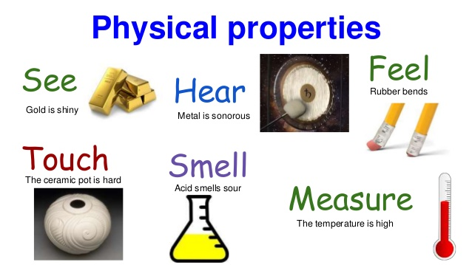

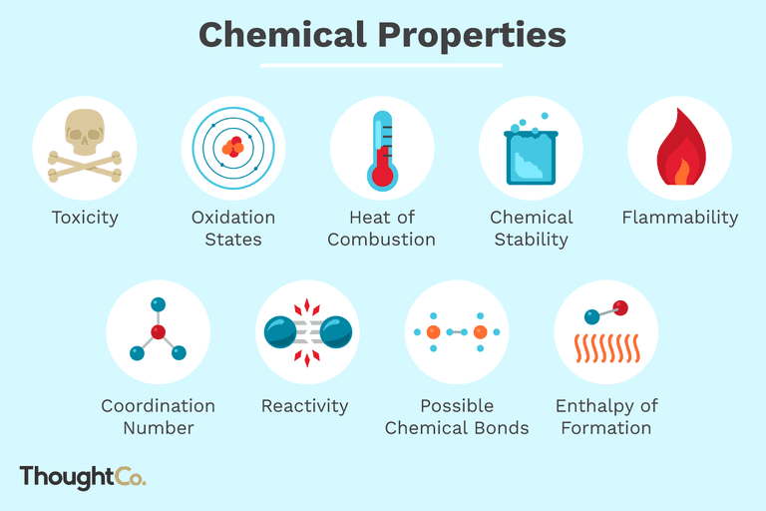

Problem solving:

Instructions:

Show students a few objects and try to describe their properties togheter with students - write new English words on the board.

- Explain each change and property to your students with an example.
- An example of a physical change would be shape. You can explain that shape is a physical property. For example, a rectangle can be broken down into triangles, but it would still contain the same amount of mass.

Guided practice
Ask students to work in pairs, they use computers or tablets to create a very short game in Scratch.
They have to choose one object, give it appropriate Spirit and write the Script how does the object change after some action will be done with it. It can be physical or chemical change. Then the Spirit ask the question: -What will happen with me, if.......? There will be two or three possible answers.
The player should click the right answer, then the Spirit will change suitably or not.
- Ask your students to change the seats in order to try different games
- Go over the questions as a class.

Support
- Show your students one example of a physical change and one example of a chemical change through a drawing. An example could be fireworks for a chemical change and cutting a paper for a physical change.

Review
- Ask your students to pick an object. Have them think of a physical change or chemical change. Instruct your students to tell two properties that would change as a result of the change.

