A Science lesson - Density

Topic: Sink or Float
Objective: The students will be using scratch to test whether different material will sink or float.
Teacher Background Information:
Density is the relationship between an object’s volume and its mass.

Volume is the amount of space the object occupies, and mass is a measurement of the amount of stuff in the object, sort of like weight. An object with a lot of mass can have a low density if it is very big, and an object with little mass can have a high density if it is very small.
If you place something in the water that is less dense than the water, it will float. However, if you drop something into the water that has a mass that is greater than the mass of the water, it will sink.

Procedure: To introduce the lesson, I will ask the students to name several objects that both float and sink. I will then ask them to tell me why they think that those specific items float or sink.

https://scratch.mit.edu/projects/262788873/#editor

Script in Scratch:
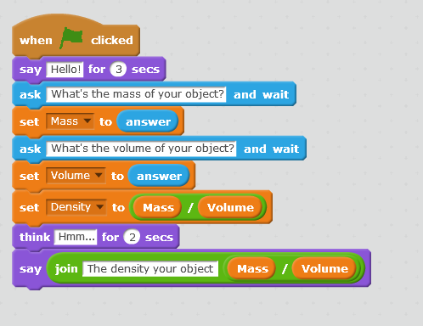

Your project looks like this
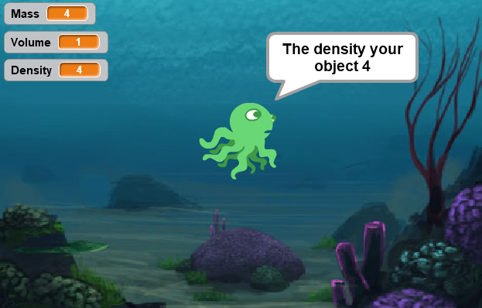
Task I for students:
Insert a new scene and a new ghost so that you can throw cubes of different materials (of different density) into a glass with water. Materials with a lower density than water will float and dense with higher density.
task II
The task consists in changing the liquid in the glass (different density) and throwing cubes-the walls.

