Foto Safari
Can you find this place in Zamość Old Town?
Find these places, take photos there in which we can see four faces of you and the place!
the numbers doesn't matter... you choose where to go first:)
READY.. STEADY... GO!
1. Climb the stairs from which you can see the lake and forest. Take a picture on these stairs.
2. Find the place where Walerian Łukasiński was prisoned, take a picture with the gate close to this place.
3. This place was a ritual Jewish Pool, is situated in Zamenhoffa Street.
4. This place was build by Zamoyski to collect all his war trophies,cannons and gunpowder. It has got old buildig and new modern one where is multimedial museum.
5. Just go to the Park and take a picture with the lake in the Park or with some flowers.
6. Now take a picture with Old Gate to Lublin.
7. And with a New Lublin Gate on the wooden bridge.
Now it is time to meet together at the main squere..........
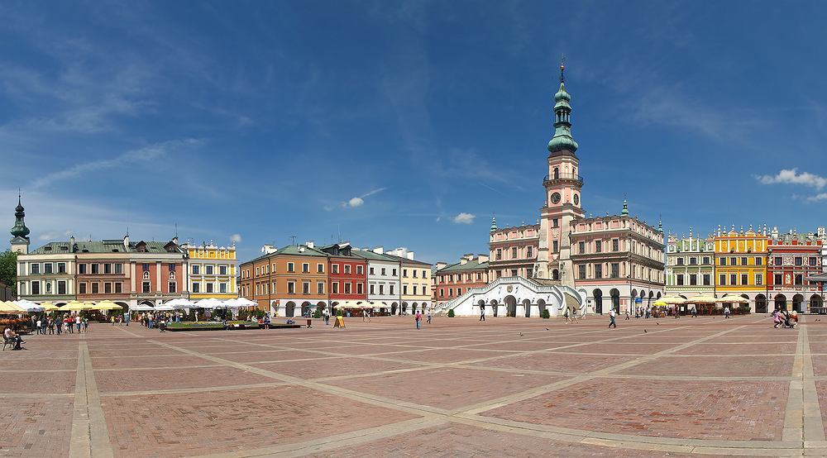
Don't forget to show your friends also:
Rotunda, Zoo, Climb the tower of Cathedral - it is very cheap
You can do it today !

